**DashBoard Contents**

**First:**  Confirm which excel we will use - Task3-aggregate to City_v3.

Add another data source to dashboard: Task3-aggregate to Monthly with City – I uploaded it to the share fold for reference

**Second**:

1. General story description (Story sheet)

2.

1. dynamic picture for #Gun VS # killed during passed 5 years
2. Use scatter chart to show where the crime occurred on map.
3. Use scatter plots to show Number of killed on map
4. Use scatter plots to show Poverty Rate on map
5. Use scatter plots to show Median_income on map
6. Number of Guns and number of incidents in different States
7. Number of Guns and number of Killed in States in different States
8. Number of Criminal VS Poverty Rate & Median_Income in Different States
9. Relationship between #guns VS #Criminal
10. Share Race VS Criminal in States
11. Race VS Incident & Injrued & Killed &Robery
12. Participants Distribution
13. Participants VS Gender
14. Number of Killed VS Gun types
15. Avg Incident Per Month Per Capital in each State
16. Avg Incident Per Month

And all related two variables

In total 30 sheets

add several new sheets related to time changes – from 2013-2018

3. Added a dynamic graph to show the relationship between the number of guns and the number of deaths – I added it as the 1st sheet.

#guns VS killed in 5 years

4. according to the year/month data source finding:

**How to interpret the data depends on the position of the person using the data and graphs. If you want to ban the use of guns, please focus on the analysis of the increase in the number of guns after 2013, and the death toll has risen sharply since 2014.**

**If you think you don’t need to tighten guns, please analyze the results after 2014; there is no direct correlation between the number of deaths and the number of guns after 2014.**

**From the perspective of quantitative changes, the number of guns has increased since 2014, not directly related to the number of deaths. However, due to the increase in the number of guns, the number of deaths after 2014 has increased significantly. It can be concluded that when the number of guns reaches a certain threshold, the number of deaths will reach a peak, and there is no obvious correlation between the number of guns and the number of deaths.**

**—————— we need to discuss with Imad for this.**

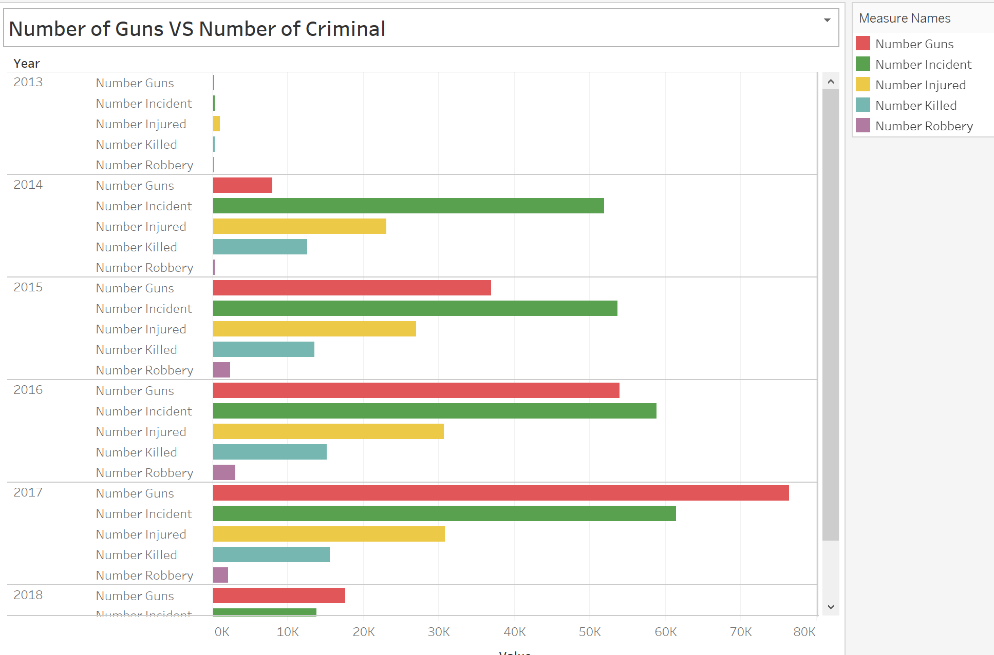

5. Derek, I add these new sheets I think you can use: (These two sheets show the distribution in general.

#Guns VS # Killed/year – I put it as the 6th sheet

#Guns VS # criminal /year - I put it as the 7th sheet

**We show the real data obtained from the data and give conclusions. You can add one point. Since 2014, #gun has reached the number (?). After that (2014), there is no direct relationship between the number of guns and the number of deaths, but the number of deaths far exceeds that in 2013. This shows that the importance of the number of banned guns. - （Here we also need to discuss with Imad, this conclusion related to our final report）**

6. the sheet below will show the data in cities/States

#GunsVS #Criminal/State/Year

I randomly chose several states as below:

From the picture, we can see that the number of guns increased, but the criminal numbers are not increasing accordingly after 2013.

